St John’s CE Kearsley gets ‘HEARTSMART!’
September 2017 saw the launch of a new powerful toolkit to help the children of St John’s learn how to be smart with their heart so that they can grow into thriving adults. It’s called HEARTSMART and is the brain child of Dave Hill who works alongside Liverpool and Manchester Diocese.
HEARTSMART is a creative way of enabling children to adopt a growth mindset whilst maintaining a healthy emotional self. It works on the idea that meaning comes from relationships and every child is worthy of relational connection. HEARTSMART is therefore about loving and accepting ourselves as well as loving and responding well to others.
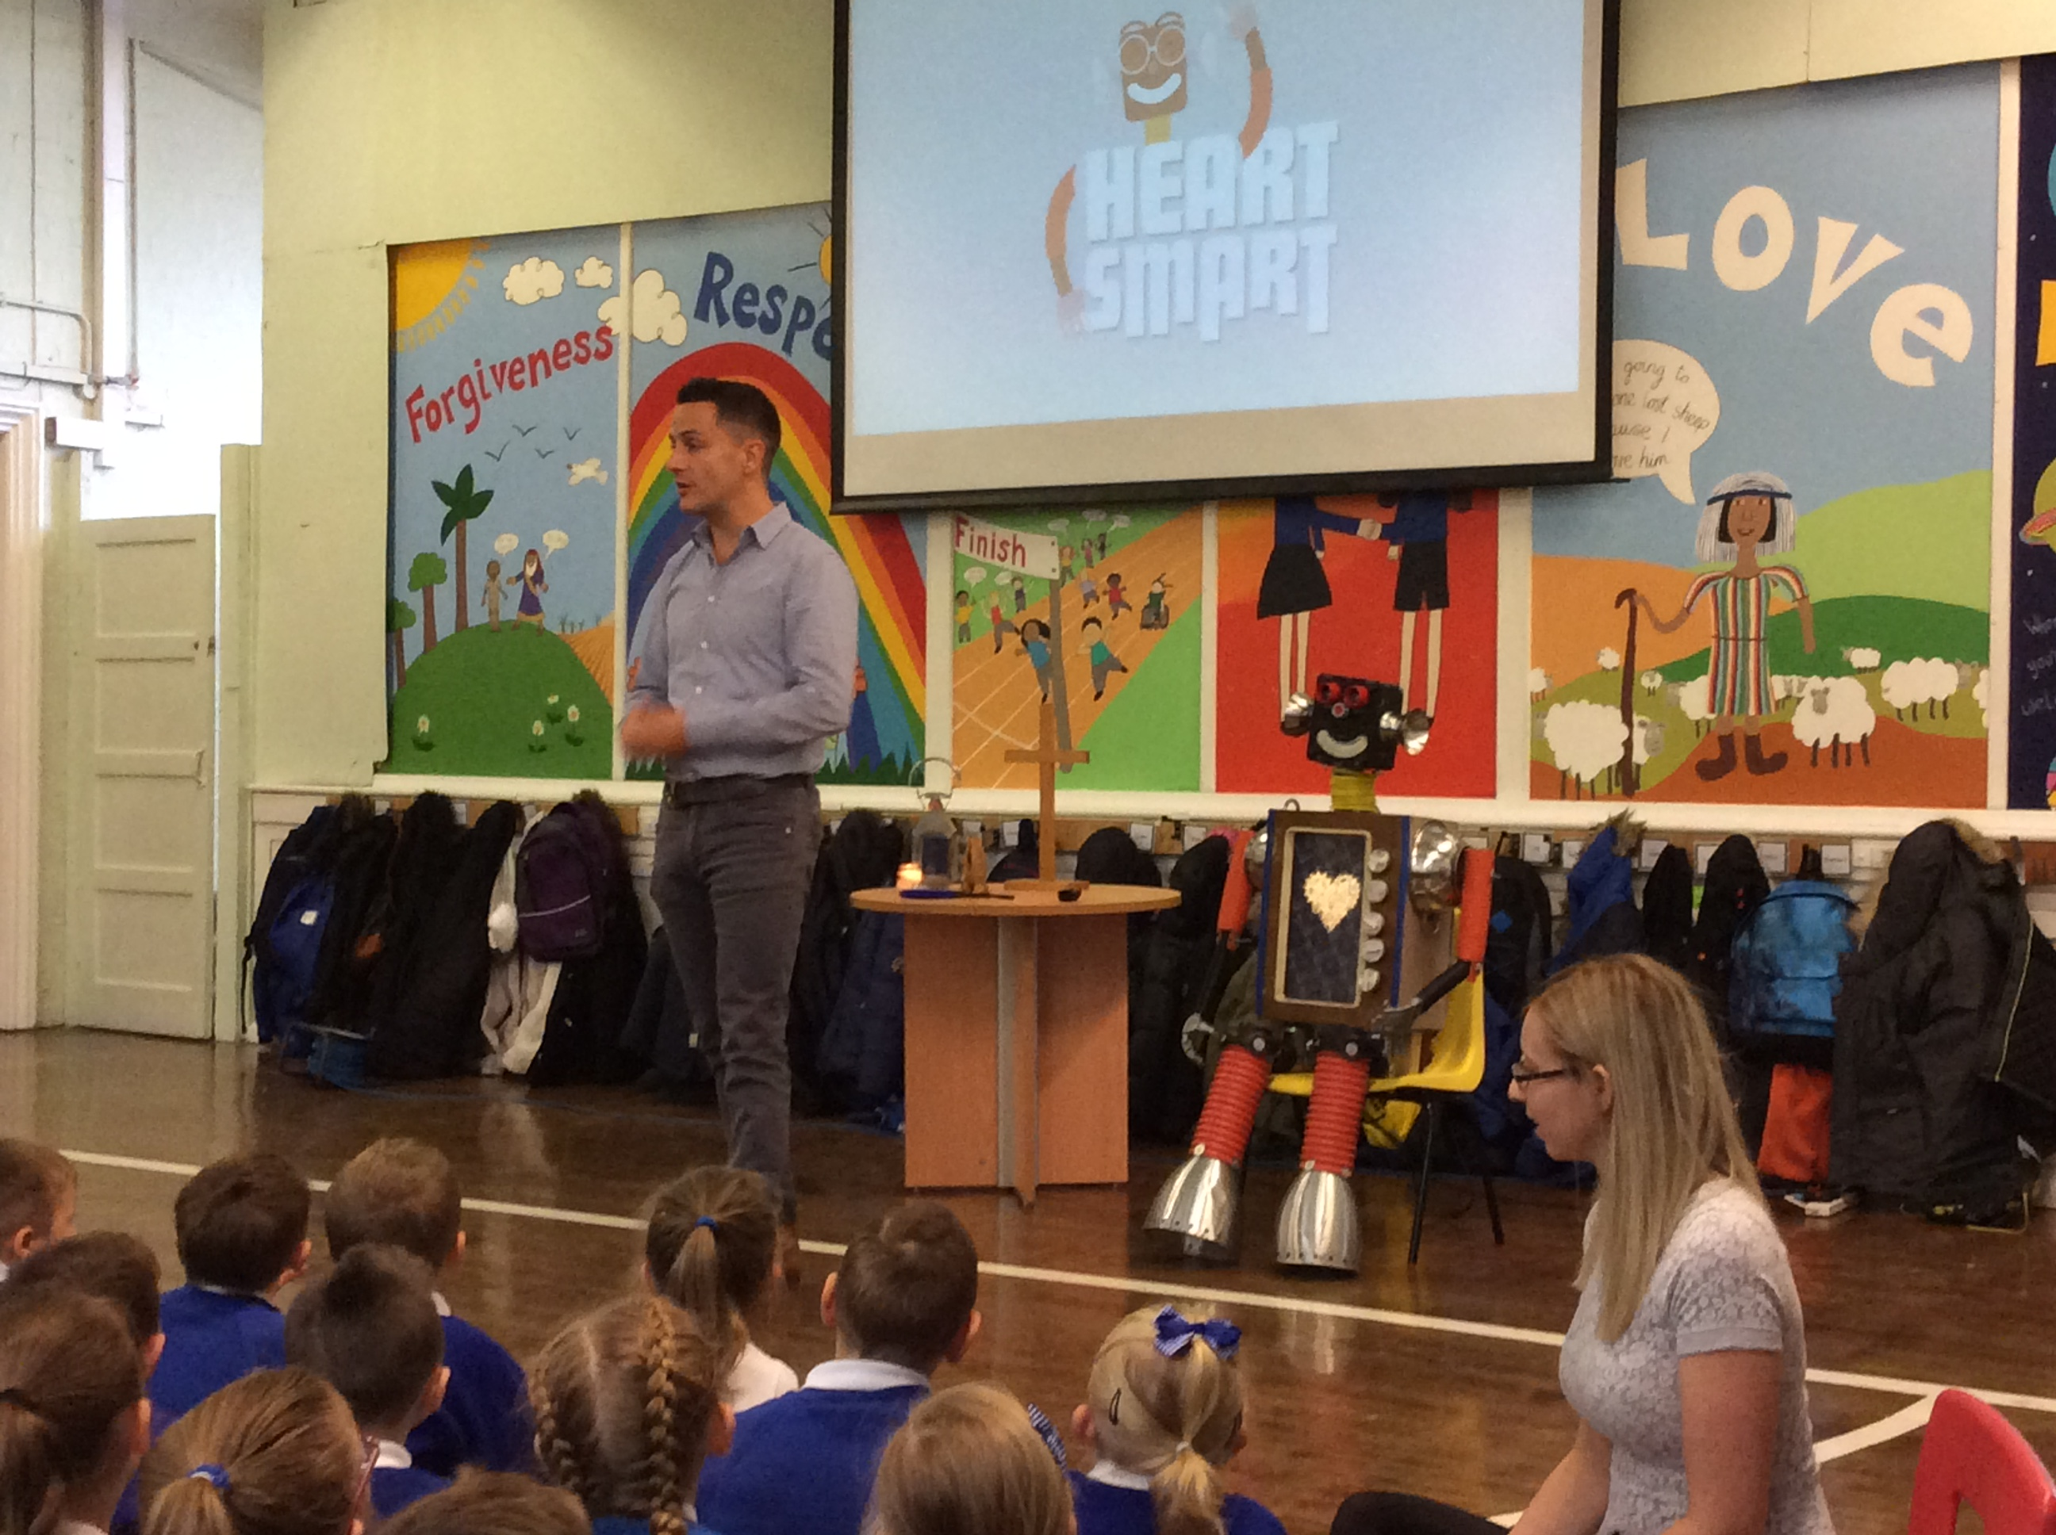
Dave explains ‘The life of our hearts affects the whole of our life. What’s in our heart will always be played out. Our lives will be greater or worse, more courageous or more fearful by what’s in our heart. Therefore, learning about how to lead our heart, when to lead from our heart, how to process pain, how to hope and how to love others is essential in learning about how to live.’
We were lucky enough to welcome Dave and his Robot ‘Boris into our whole school worship where Dave introduced the children to Heartsmart and the HeartSmart High Five. The programme is focussed around Boris the Robot which helps to motivate children to become actively involved with the programme and learning. There are 5 themes (known as ‘High Five’) that Boris shares throughout the year which are linked to the principles of feeling valued, considering others and showing empathy, forgiveness, being truthful and not giving up when faced with challenge. Through these catchy principles, the children learn what it means to be a powerful person, how to make good choices and how to love themselves and those around them well. The programme is designed to support children to build resilience, emotional intelligence and active empathy.
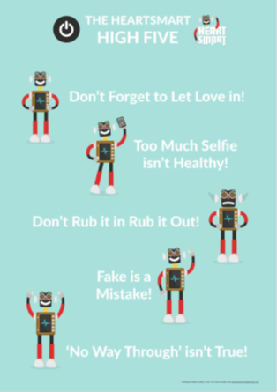
Each half term we have introduced one of the ‘High Five’ in our whole school Worship; this is then covered in more depth through the half term in both Worship and PSHE lesson in class. Rev Carol and Paul Saxon from Zac’s Youth Bar also continued the theme in their Thursday Worship at St John’s Church.
Rev Carol was so impressed that all of the children know the ‘High Five’ and can immediately relay it back to her.
Here’s what some of our children think about Heartsmart so far this year:
‘I’ve learnt that being ‘Fake is a Mistake’ – we need to be ourselves! – Riley
A small lie can become a big lie – we always need to be honest – Sophia
‘It teaches kids in a fun way what you can do to care for each other’ – Melissa
Fake is a Mistake – you are not loving yourself if you are being fake! – Zack
All teachers help us to be kind to ourselves so that we can be kind to others’ – Khaleel
Suzanne Howard
Headteacher

