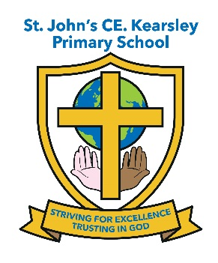

St John’s CE Primary School
Head teacher’s Report for the Parish
(January 2021 - December 2021)
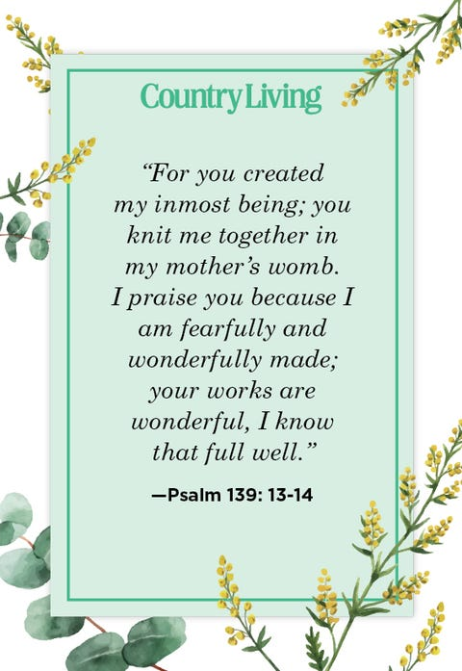

This year’s report follows what can only be described as one another of the most challenging times our children and families have ever faced. The school continued to work tirelessly with its local church and community to press forward with raising standards despite the global pandemic. I feel exceptionally proud of all the children of St John’s have achieved over the last year and look forward to the future now that we are able to get back to normal and ‘Living with Covid’

Spring term 2021

Unfortunately just as the Spring term started and we were looking forward to getting back to normal at St John’s the second lockdown was announced. The school opened its doors to every year group across school and tried to get as many families back into school to support the community during such challenging times.
For the families who didn’t want to risk bringing their children into school the school did its best to provide suitable learning opportunities via it Remote Learning Policy and TEAMS to all children at home during this time and ensured appropriate support for families at the point of need through our Pastoral Officer and Behaviour and Engagement Mentor making welfare calls to families and sign posting them to agencies and charities throughout the second wave of the pandemic.
Manchester Diocese supported all schools by providing spiritual guidance with weekly remote worship and this was invaluable at St John’s in support our children Christian journey whilst they couldn’t be with us in person – as well as providing mental well-being for children and families at home.
Upon our return in March our Reception were able to hold three ‘Wiggle Worship’ sessions led by Steph from Changing Places Team – this event was held separately for each bubble and unfortunately could not include parents this time.
However Experience Easter at St John’s Church had to be cancelled due to COVID restrictions.
School managed to ensure we held an Infant and Junior Easter Service at St John’s as normal with all classes taking part and retelling a portion of the Easter Story. This was recorded and uploaded to Twitter and the school’s FB account for parents to share in. School continued to hold its annual Easter Egg Decorating competition – albeit is as colouring competition across the school with prizes awarded for 1st, 2nd and 3rd place per class. The Junior Unit also held a hard-boiled Egg decorating competition where children could submit their creations via TEAMS and prizes were also given out for this too.
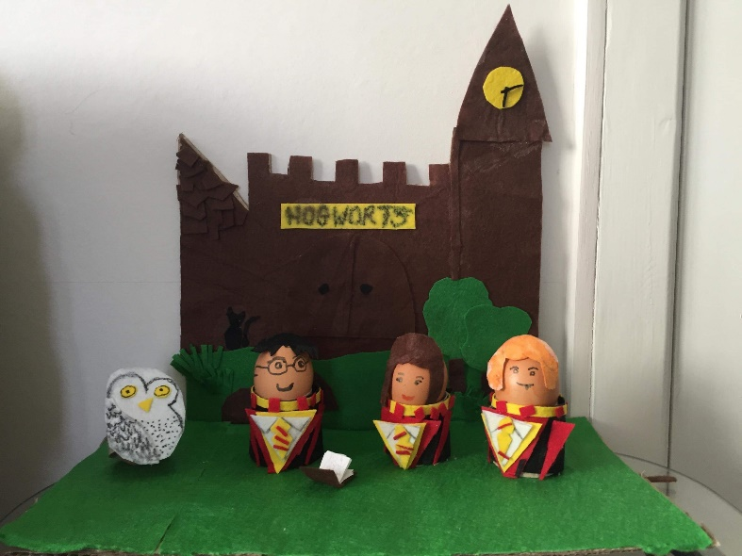

Summer term 2021

Thankfully St John’s opened its doors to all children again for the Summer term and it was so wonderful to have all of our children back with us again.
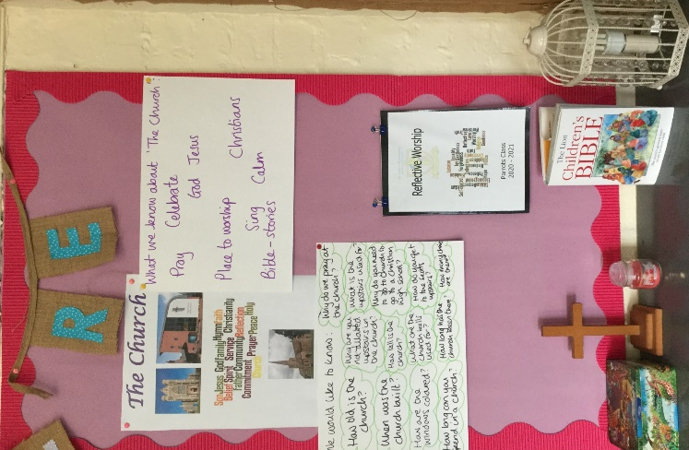

St John’s just wasn’t the same without the children and for many it was their ultimate faith that God had a plan for us all that got us through such a mentally and emotionally challenging time for all concerned.
During the summer term school were still unable to return to their normal weekly worship in St John’s Church however as restrictions were lifted in July we managed to hold the Y6 Leavers’ Service on Thursday 22nd July which was well attended by families and the children received a copy of the Bible as a gift from the PTA and a ‘Moving On’ book from St John’s PCC to take with them to their secondary school.
The Changing Places Team offered a series of Y6 Transition sessions which were really well received and called ‘The Emoji Project’ – it consisted of three workshops to build self-esteem, encourage positive wellbeing and promote good mental health. Children discovered they can be HOPEFUL, BRAVE and KIND and create their own emoji survival kit. Linking to Bible stories and verses that will inspire everyone as they continue their spiritual journey at secondary school.
The Infant classes had a visit from the Wiggle Worship Team looking at following on from the Easter story, how Jesus appeared to his friends after he rose again. Unfortunately due to the timings of this we were unable to involve the parents as we would have wanted to.
Autumn term 2021
During the Autumn term school was initially able to return to their normal weekly worship both in school and at St John’s Church however restrictions were put back in place by Bolton Local Authority from 18th October due to a rise in local cases. As such worship resumed on line within school and Father Stephen suggested coming into school on the Thursday morning to deliver worship to one year group at a time.
So in the Autumn term Y6 and Y5 had a visit from Father Stephen, this continued throughout the Spring term too – with all classes looking forward to their weekly visit form Father Stephen.
The youngest members of school attended their own New Reception Service at St Johns’ on 23rd September where they were officially welcomed into the family of St John’s and all received a wooden cross as keepsake to start their spiritual journey in school. They were accompanied by their Y6 Buddy as part of our newly introduced ‘Seeds and Gardeners’ Student Leadership Group.

We also were able to hold our annual Harvest Services for both the infants and juniors which were well attended and all food donations went to Farnworth Foodbank – the generosity of our families under difficult circumstances amazed me, as always.

The Changing Places Team visited to meet the new Ethos Team however due to staff absence this visit had to be postponed until the Spring term.
The Infant classes had a visit from the Wiggle Worship Team. Unfortunately due to the timings of this we were unable to involve the parents as we would have wanted to as Covid restrictions were now in place again.
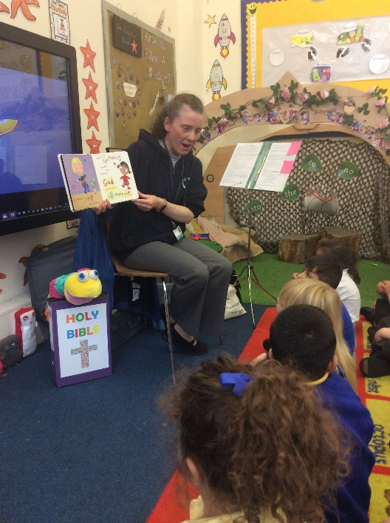
Thankfully due to the hard work of the PCC and St John’s congregation the children in Year 3 were still able to take part in Experience Christmas over at St John’s - this was wonderful and very much appreciated by staff and the children.
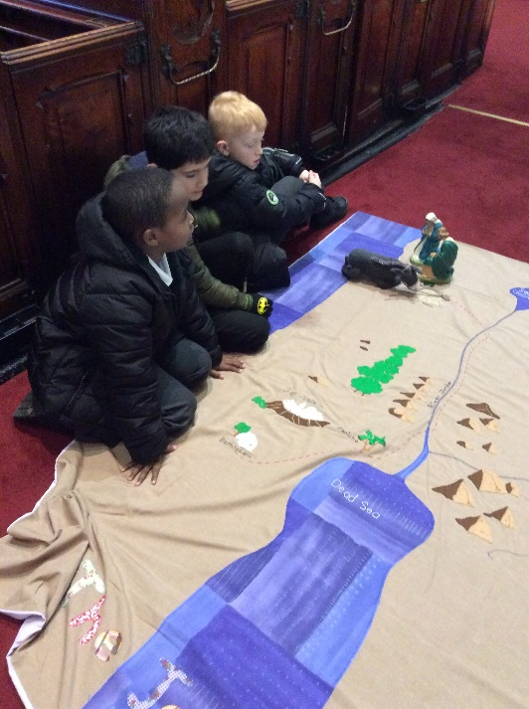
The decision was made to once again film the Christingle Services, the Tree Dressing Ceremony, the Infant Nativity and the Junior Carol Services. Due to the hard work of the staff and the support of the families no child missed out on these wonderful events in spite of the local Covid restrictions in place. All families were able to access the links to watch the events from the school FB Page and Twitter.

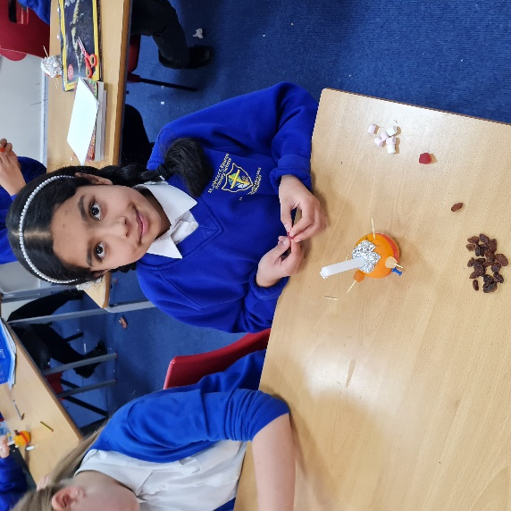

Finally I would like to thank all of my children, staff and Governors for all their hard work and continued support through what has been a very challenging time for the family of St John’s.
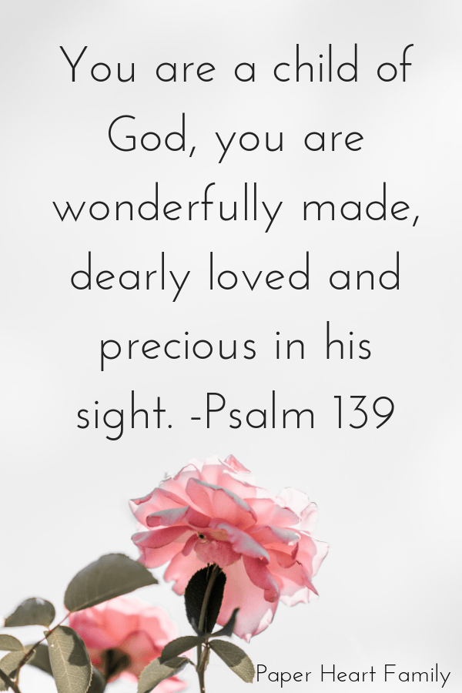

Suzanne Howard
Head teacher of St John’s CE Kearsley

