Looking Back
St John’s CE School 1929 – 1939
My School Day Memories
By Phyllis Bennett
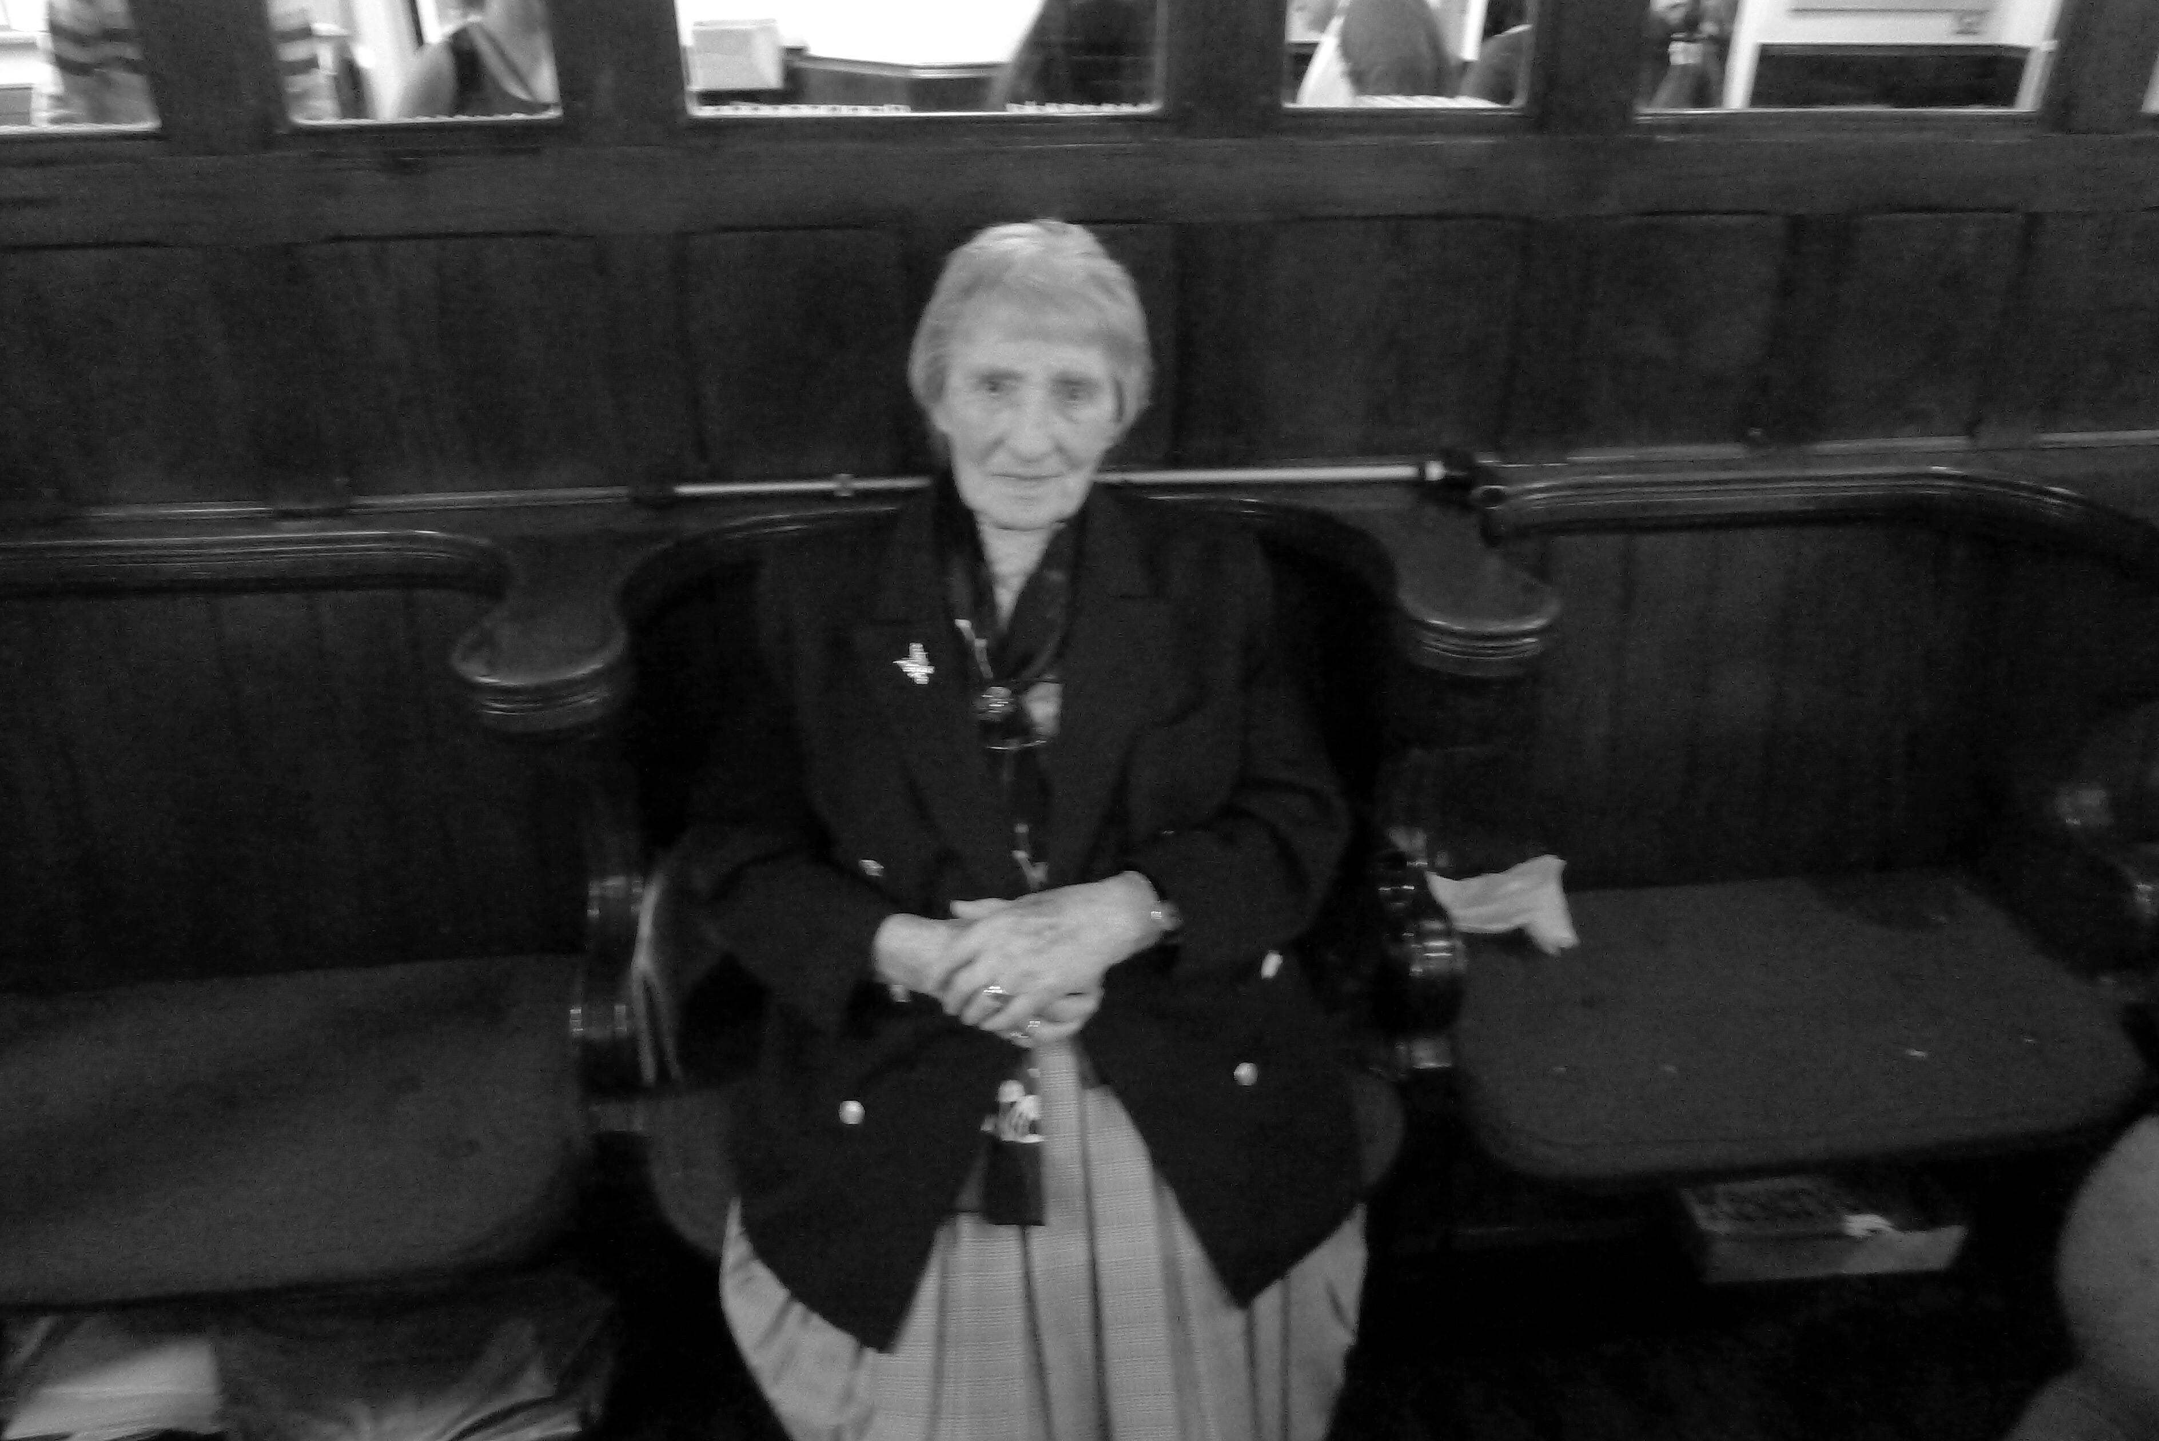
I started attending St John’s School in 1929, when I was 3 years old and I left in 1939, when I was 14 years old. The leaving age was changed to 15 years of age in 1939 but I left 6 months early when I was 14, due to the start of World War 2.
In those days St John’s was three schools in one – Infant, Junior and Senior; each school group had its own hall. The infant’s hall was at the rear of the school on the ground floor and led onto the back playground; the junior hall was also on the ground floor but at the front of the school. The upstairs hall was used by the senior pupils. From an external perspective the building is much the same today as it was then. The front yard was used by the boys, whilst the back playground was used by the girls and infants. I remember, when I first started school, that the back yard toilets were ‘tipplers’ and situated at the bottom. I can clearly remember a new toilet block of water closets being built in 1930. These are no longer there and were demolished many years ago.
The ground floor of the school was always referred to as ‘the downstairs’. This housed three infant classrooms with a further class being held in the infant’s hall. The junior school consisted of the junior hall, two classrooms and the Committee Room (used today as the Community Room). The Committee Room was used for church council meetings and also doubled as a classroom for Standard 3. The entrance to this room was through a solid wooden door facing the front entrance to school. It had a fireplace with an open fire and there was a large floor to ceiling cupboard at the back of the room where church stored the Walking Day banners, which were used for the Whitsuntide procession.
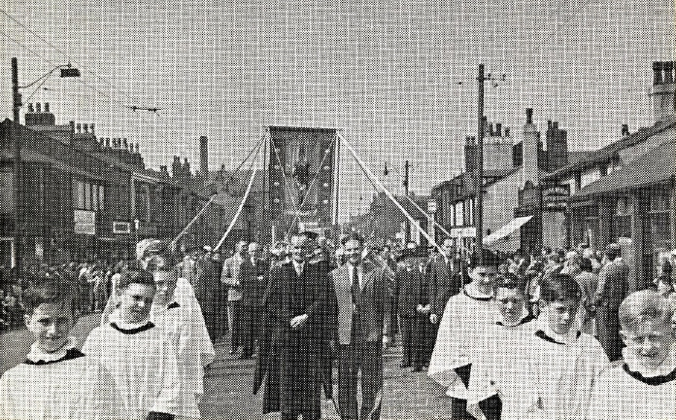
Walking Day 1940 in Higher Market Street, Farnworth
One of my few memories of my first class (infant nursery class) was being given a mid-morning drink of Horlicks in a little cup which had pictures of nursery rhymes on it. There was a fireplace in this room as well with a large fireguard around the hearth. I can also remember this class having a sandpit, which everyone enjoyed playing in. Another memory I have of those early days is that in the afternoon we had a sleep on canvas beds which could be folded away when not in use.
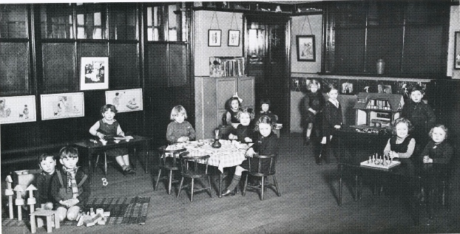
St John’s Infants Class 1937
When we moved into the next infant class and started to learn to write, we wrote with chalk on slates. We also had plasticine which we would roll out on a board and make into the shape of letters of the alphabet. At the end of each term we took our plasticine board home and scrubbed it, ready for further use.
The head master was Mr Hall and he was very interested in music. I remember him telling us about the work of his predecessor, Mr Charles Frederick Howard and there is a stained glass window depicting the hymn ‘We Plough the Fields and Scatter’ in his memory in church. The church website contains a comprehensive article about him, which was written by Arnold Cragg. Mr Hall was later ordained Deacon and after assisting in our parish went to work in the Deanery.
When we moved into junior school, Miss Howard (Mr Howard’s daughter) was our teacher in Standard 2. She taught us to knit squares and when we had completed a square we stood on our chair to let her know that we had finished it.
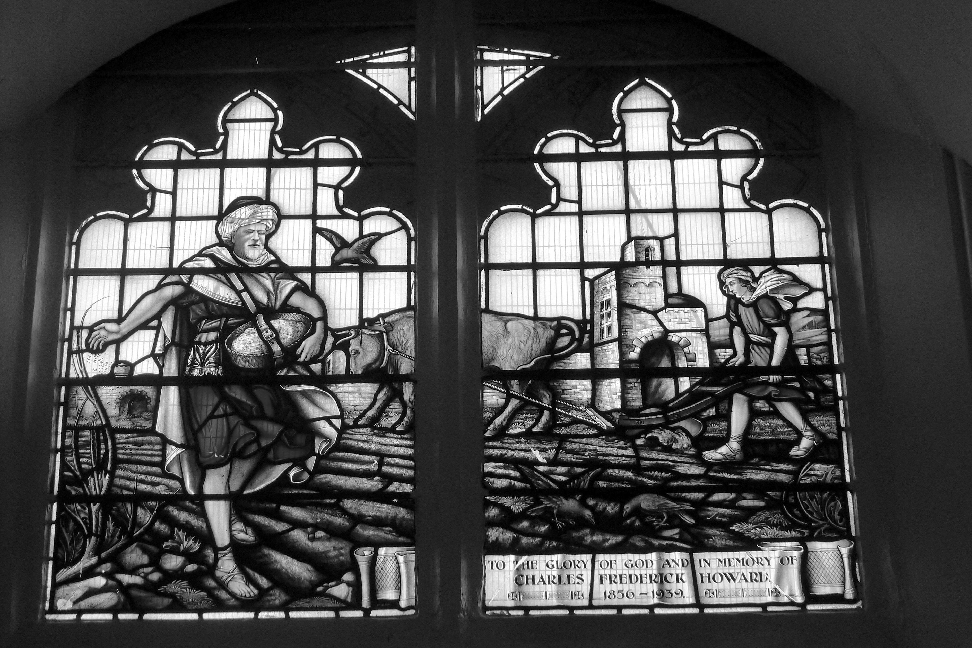
Window in St John’s Church dedicated to Charles Frederick Howard
At Christmas she gave all the pupils in her class a brand new shiny penny. She was able to obtain these through her brother, Mr Lesley Howard, who worked in a bank.
The hymns for assembly in the junior hall were written on a flip chart so that we could learn the words and I can still remember most of them to this day.
When we moved upstairs into senior school, an assembly took place every morning at 9.00am, during which we used hymn books. Immediately after the assembly we went to our various classrooms for lessons. There were six classrooms upstairs and two additional classes for boys were held in the upper hall. The classes were mixed up to Standard 5, when we were aged 11. After this in Standard 6 and 7 the boys and girls had separate classes.
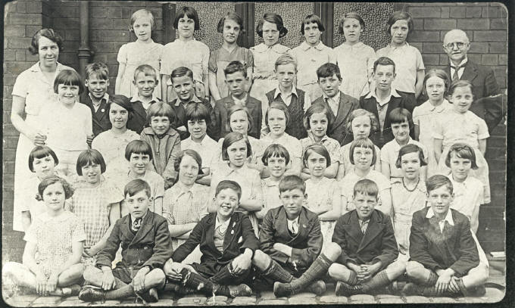
St John’s Standard 5 (Scholarship Class) in 1936. The two teachers are Mrs Appleton (class teacher)and Mr Hall (head teacher). I am on the back row next to Mr Hall.
I remember when I was 12 years old in Standard 6 going to Kearsley West School for cookery and housewifery lessons. I had one term of laundry and three terms of cookery.
We didn’t have gym lessons, but the boys played football and the girls did country dancing. Every year we had a sports day on St John’s playing field. On Walking Day after the Whitsuntide Procession, the scholars were given coffee and buns in the school hall following which they went onto the playing field. The head teacher sat in the middle of the field shelling peanuts which he scattered for the children.
When you were in Standard 7 you could have a bank book. You took your money to school on Monday morning and school banked it for you with the Yorkshire Penny Bank which was on Market Street in Farnworth. We had to pay 1/2d (one ‘old’ half penny - equivalent to 1/5th of today’s 1 penny) for our milk which was supplied in a 1/3rd of a pint bottle. When I was in the top class I was the milk monitor and collected the milk money.
The school day was 9.00am to 12 noon in the morning and 1.30pm to 4.00pm in the afternoon. Most children went home for lunch unless you father was out of work and then you could go to New Jerusalem, Kearsley for a free school dinner. The school day always closed with prayers.

