The Appearance and Location of St John’s Church
By John Lever
What does St John’s church look like and where is it? Well, it’s quite straightforward. It’s a fine building of large sandstone blocks with a tower and it’s at the bottom of Church Street. So far, so good. But if I were to ask, is the actual appearance of St John’s what was planned and is it where it’s supposed to be? Then things are not so simple anymore and we uncover an interesting story which concerns two key figures.
The Reverend James Slade was a distinguished individual who did a great deal of good for the people of Bolton. Described as a model reforming clergyman and an inspired preacher. Northamptonshire born, Cambridge educated Slade was the vicar of Bolton Parish Church from 1817 until 1856. His Sunday schools regularly had a total attendance of 1,300 scholars, he was involved in the founding of Bolton Royal Infirmary, Bolton Savings Bank and the Bolton Church Institute which later would become Canon Slade School. James Slade also oversaw the building of approximately a dozen new churches during his tenure, including our own St John’s.
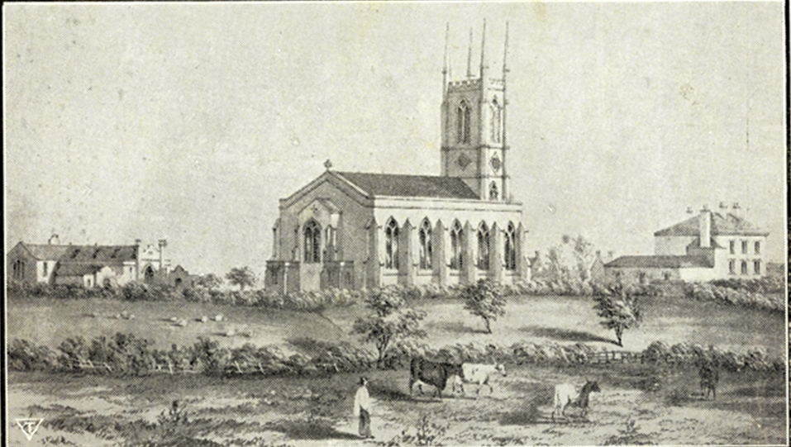
St John’s Church circa 1826
St John’s was one of the first Commissioner’s or Waterloo churches to be built. These were churches built using a grant of money from Parliament, following victory over Napoleon in the battle of Waterloo, to give thanks and to help accommodate an ever increasing number of people. Thanks to the Industrial Revolution, the population was rapidly growing and the capacity of the existing Anglican churches was insufficient.
At the same time as St John’s, the construction of All Saints Church, Stand (Whitefield) was also under consideration by the Church Building Commissioners. In fact both churches were consecrated on consecutive days in 1826. We have already stated that St John’s church is no doubt a fine building, in the gothic revival style. However, students of architecture would undoubtedly much admire the merits of the fanciful gothic All Saints, being the first building of the famous architect Charles Barry who would go on to design the present Houses of Parliament.
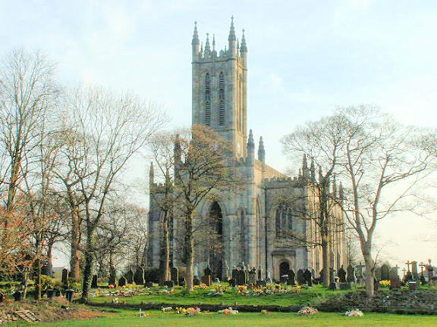
All Saints Church, Stand
The original intention was that the church that was actually built at Stand would be built in Farnworth and vice versa. It seems however that Canon Slade was of the view that the church now at Stand would be much too large, for a considerable time to come, for the needs of Farnworth and in the event it was decided that the larger church would in fact be built at Stand and the smaller one at Farnworth.
As an aside, at the time of these events, Bolton Parish Church was not the beautifully proportioned, spacious building, with its 180 foot tower (reputedly Lancashire’s highest parish church tower), that we know today. Indeed, the present Bolton Parish church was not consecrated until 1871. Canon Slade’s church was its much squatter, 15th century predecessor, which was apparently falling into disrepair.
Having said that, Canon Slade, who died in 1860, dedicated himself to improving the conditions of the people of Bolton and was undoubtedly very well respected in Bolton. He was buried in the last church that he oversaw the construction of; St James, Breightmet and it was estimated that 5,000 people lined the route of the cortege from his brother’s house to the church.
Have you ever wondered why St John’s isn’t on a main road, whereas many similar sized churches in other towns tend to have a more primary location? Farnworth industrialist and benefactor Benjamin Rawson had been the main driving force in the movement for a church at Farnworth and he generously donated the land on which the church was to be built. Rawson, whose name lives on in the thoroughfare Rawson Street and the public house which formerly stood on that street had originally intended to allocate land at the front of his estate, boarding onto Bolton Road or Lower Market Street, for the building of the church.
It is recorded however that Mr Rawson was dissatisfied with the new arrangements of building the church intended for Farnworth in Stand and that intended for Stand in Farnworth. Accordingly, in response to this change of arrangements, Rawson in turn refused to allow land at the front of his estate to be used for the building of the smaller church and instead allocated land at the rear. This indeed became the site of our church, St John’s at the bottom of Church Street.
This article appeared in the April 2018 issue of St John’s Magazine

