The Ring of Bells to Celebrate
The Coronation of Queen Elizabeth II in 1953
It was decided in 1953 to recast the 8 bells at St John’s Church to commemorate the Coronation of Queen Elizabeth II. However, the castings were not completed until 1954. The 8 bells, which still hang today, consist of various sizes and consequently different weights. The smallest (Treble) of 2’ 1” diameter and weighing 468lbs (212 kg), increasing in size to the largest (Tenor) of 3’ 4” diameter and weighing 1380 lbs (626 kg).
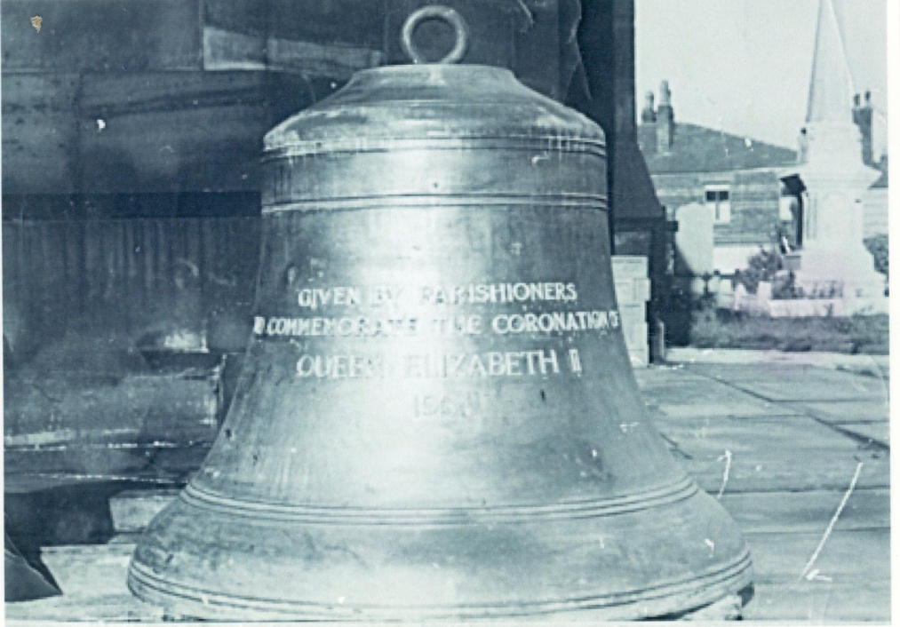
The largest bell, the Tenor, was given by the parishioners and the reason it wasn’t cast until 1954 was because they hadn’t raised sufficient money to pay for it in 1953. The cost of the inscription was one shilling per letter, making a total cost of 67 shillings (£3-35p). I am sure that some of the congregation will remember the ‘Clock and Bell Fund’ which was started when Rev L P Burnett was vicar, together with the fund raising Potato Pie Suppers. Mrs Alison Rushton (Norma Rushton’s mother) was usually tasked with making the potato pies, despite the country still being in the grip of food rationing following World War II.
The cost of the other bells was defrayed by the Bell Ringers who gave the Treble; the family of the late Frank and Gertrude Warburton; Mrs E G Botham; Fred and Arthur Watson; Miss Edith Whittaker; John H Proffitt and Mrs C Rostron; Miss Elsie M Coupe, whose grandfather had given the original 6th bell in 1899.
The 1899 Ring of 8 Bells was hung by Thomas Blackburn of Salisbury with the largest bells being hung on the outer edge and the smaller bells on the inside. The ringing of the bells made the tower shake so much that the four pinnacles, which were at each corner of the church tower, were taken down in 1912 as a safety precaution. As part of the Commemoration of the Centenary of the Church in 1926, the bells were fitted with an electric motor to allow mechanical ringing. When the bells were re-hung in 1954, by the famous bell founders John Taylor of Loughborough, the configuration of the bells was changed with the smaller bells being hung on the outer edge and the larger bells on the inside.

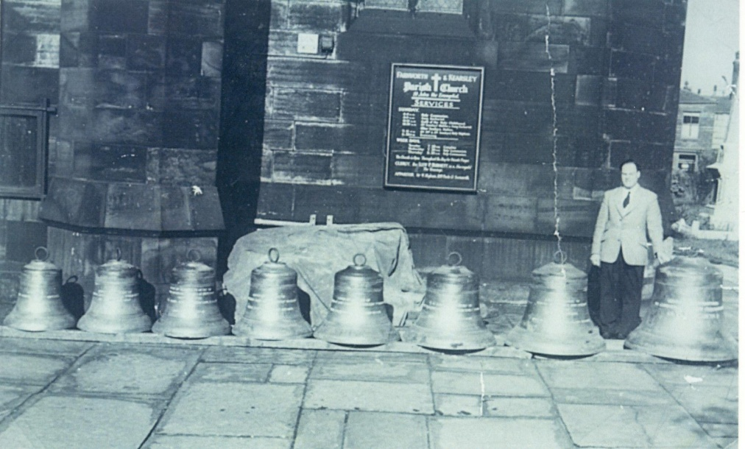
In the above picture I am standing next to the Tenor Bell, before it was hung along with the other seven. I remember each class from St John’s School coming over to look at them.
Joe Thornley
Former Bell Tower Captain
(Joe was born on the same day as the Queen in 1926 and wished to share his memory of the commemoration of the church bells as part of the celebrations to mark the Queen’s 90th birthday)

